Part 4

15) Integrity && Efficiency: When the integrity increases, the system will affect efficiency. As making the system more secure, as it can not limit any entry to the private data on the site except the administrator to amend or accept the addition of an item for sale and not to allow this to anyone, Check passwords where only non-subscribers are allowed to enter and upload the product to the site, and this is done by confirming the password and making sure it is secure which makes the use of a specific al gorithm or authentication server and this affects efficiency.

**16).**

The (CCM) =1 for the function add and 1 for all if, else, and 1 for all operators || that mean the function =5.

LOC → 19

LOC → 16

The (CCM) =1 for the function add and 1 for all if, else, and 1 for all operators || that mean the function =2.

LOC → 19

The (CCM) =1 for the function add and 1 for all if, else, and 1 for all operators || that mean the function =4.

LOC → 22

The (CCM) =1 for the function add and 1 for all if, else, and 1 for all operators || that mean the function =3.

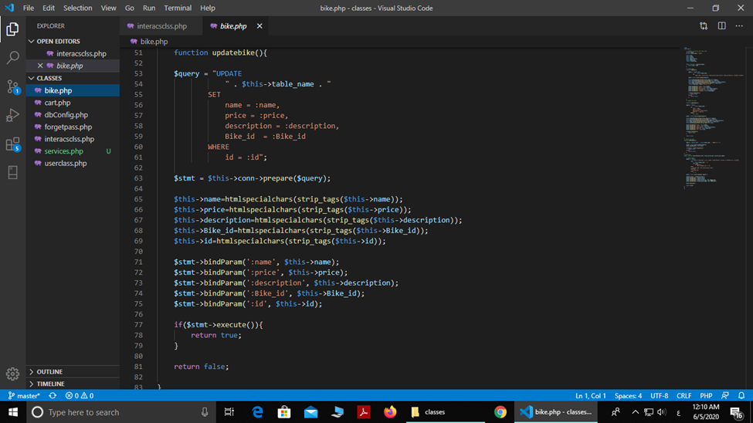

LOC → 27

The (CCM) =1 for the function add and 1 for all if, else, and 1 for all operators || that mean the function =3.

LOC → 10

The (CCM) =2 for the IF AND ELSE